23/9/26
GENETIC ALGORITHM FOR OPTIMISATION PROBLEMS
import random
items = [(10, 5), (40, 4), (30, 6), (50, 3), (35, 2)]
capacity = 10
population_size = 8
generations = 10
def fitness(gene):
total_value, total_weight = 0, 0
for bit, (value, weight) in zip(gene, items):
if bit == 1:
total_value += value
total_weight += weight
return total_value if total_weight <= capacity else 0
def random_gene():
return [random.randint(0,1) for _ in items]
def crossover(parent1, parent2):
point = random.randint(1, len(items)-1)
return parent1[:point] + parent2[point:]
def mutate(gene):
i = random.randint(0, len(gene)-1)
gene[i] = 1 - gene[i]
return gene
population = [random_gene() for _ in range(population_size)]
for gen in range(generations):
population = sorted(population, key=fitness, reverse=True)
best = population[0]
print(f"Gen {gen+1}: Best gene {best}, Value = {fitness(best)}")
new_pop = [best[:]]
while len(new_pop) < population_size:
p1, p2 = random.sample(population[:4], 2) # select parents
child = crossover(p1, p2)
if random.random() < 0.3: # mutation chance
child = mutate(child)
new_pop.append(child)
population = new_pop
print("\nOptimal Solution Found:")
print("Gene:", best)
print("Value:", fitness(best))

OUTPUT:
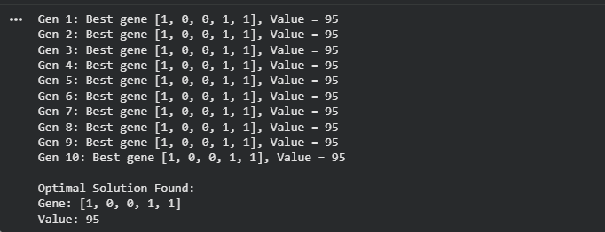

30/09/2026
PARTICLE SWARM OPTIMISATION
import random, math
cities = [(0,0), (2,3), (5,2), (6,6), (8,3)]
def dist(a, b):
return math.sqrt((a[0]-b[0])**2 + (a[1]-b[1])**2)
def route_length(route):
return sum(dist(cities[route[i]], cities[route[(i+1)%len(route)]]) for i in range(len(route)))
num_particles = 6
iterations = 10
particles = [random.sample(range(len(cities)), len(cities)) for _ in range(num_particles)]
pbest = particles[:]
pbest_val = [route_length(p) for p in particles]
gbest = pbest[pbest_val.index(min(pbest_val))]
gbest_val = min(pbest_val)
for t in range(iterations):
for i in range(num_particles):
a, b = random.sample(range(len(cities)), 2)
particles[i][a], particles[i][b] = particles[i][b], particles[i][a]
val = route_length(particles[i])
if val < pbest_val[i]:
pbest[i], pbest_val[i] = particles[i][:], val
best_val = min(pbest_val)
if best_val < gbest_val:
gbest_val = best_val
gbest = pbest[pbest_val.index(best_val)]
print(f"Iter {t+1}: Best route length = {gbest_val:.2f}")
print("\nOptimal Route Found:")
print("Route:", gbest)
print("Distance:", gbest_val)

OUTPUT:
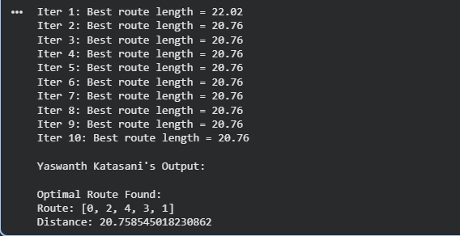

07/10/2026
OPTIMISATION VIA GENE EXPRESSION
import random
items = [(10, 5), (40, 4), (30, 6), (50, 3), (35, 2)]
capacity = 10
population_size = 6
generations = 5
def fitness(gene):
total_value, total_weight = 0, 0
for bit, (value, weight) in zip(gene, items):
if bit == 1:
total_value += value
total_weight += weight
return total_value if total_weight <= capacity else 0
def random_gene():
return [random.randint(0,1) for _ in items]
def mutate(gene):
i = random.randint(0, len(gene)-1)
gene[i] = 1 - gene[i]
return gene
population = [random_gene() for _ in range(population_size)]
for gen in range(generations):
population = sorted(population, key=fitness, reverse=True)
best = population[0]
print(f"Gen {gen+1}: Best gene {best}, Value = {fitness(best)}")
new_pop = [best[:]]
while len(new_pop) < population_size:
child = mutate(best[:])
new_pop.append(child)
population = new_pop
print("\nOptimal Solution Found:")
print("Gene:", best)
OUTPUT:
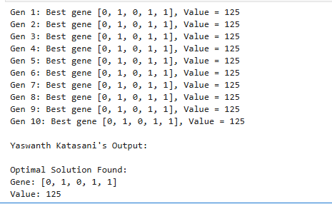

28/10/2026:
ANT COLONY OPTIMISATION FOR TSP:
import random

# --- Step 1: Take input dynamically ---
n = int(input("Enter number of cities: "))
print("Enter the distance matrix row by row:")

distances = []
for i in range(n):
row = list(map(int, input().split()))
distances.append(row)

num_ants = n # number of ants = number of cities
num_iterations = 50 # how many times algorithm runs

alpha = 1 # pheromone importance
beta = 5 # distance importance
rho = 0.5 # evaporation rate
Q = 100 # pheromone deposit factor

# --- Step 2: Initialize pheromone matrix ---
pheromone = [[1 for _ in range(n)] for _ in range(n)]

def probability(i, j, visited):
"""Probability of moving from city i to city j"""
tau = pheromone[i][j] ** alpha
eta = (1 / distances[i][j]) ** beta if distances[i][j] > 0 else 0
return tau * eta if j not in visited else 0

def construct_solution():
"""Each ant builds a tour"""
start = random.randint(0, n-1)
tour = [start]
visited = set(tour)

while len(tour) < n:
i = tour[-1]
probs = [probability(i, j, visited) for j in range(n)]
total = sum(probs)
if total == 0: break
# roulette wheel selection
r = random.uniform(0, total)
s = 0
for j, p in enumerate(probs):
s += p
if s >= r:
tour.append(j)
visited.add(j)
break
tour.append(start) # return to start
return tour

def tour_length(tour):
return sum(distances[tour[i]][tour[i+1]] for i in range(len(tour)-1))

# --- Step 3: Main loop ---
best_tour = None
best_length = float("inf")

for _ in range(num_iterations):
all_tours = [construct_solution() for _ in range(num_ants)]

# Evaporation
for i in range(n):
for j in range(n):
pheromone[i][j] *= (1 - rho)

# Reinforcement
for tour in all_tours:
L = tour_length(tour)
if L < best_length:
best_length = L
best_tour = tour
for i in range(len(tour)-1):
a, b = tour[i], tour[i+1]
pheromone[a][b] += Q / L

print("Yashwanth's 1WN24CS133 Output: ")
print("Best tour found:", best_tour)
print("Tour length:", best_length)

OUTPUT:

